|  |  |
| --- | --- |
| **Project: New Haven Urgent Care Team# 1** | |
|  | **Test Date: 12/8/2019** |
| **Test Case ID#: 12** | **Name(s) of Tester(s): Kun Ki Lee, Eric Hwang, Kyeongtak Han, Dongha Kang** |
| **Test Description (What are you testing? – you must be specific): Test if we can retrieve Nurses ID and other information through initial assessment.** |  |
|  |  |

**NOTE: The following information must be provided to be given credit for any test.**

**Test Data (Provide the file name of the script used to insert data, provide a screen capture to reflect data, or provide script here):**

**Patient Table for testing**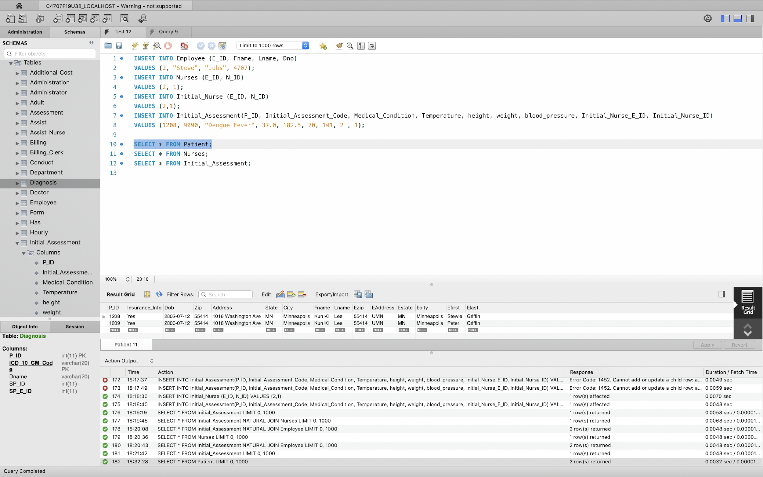

**Employee (Nurse) For Testing**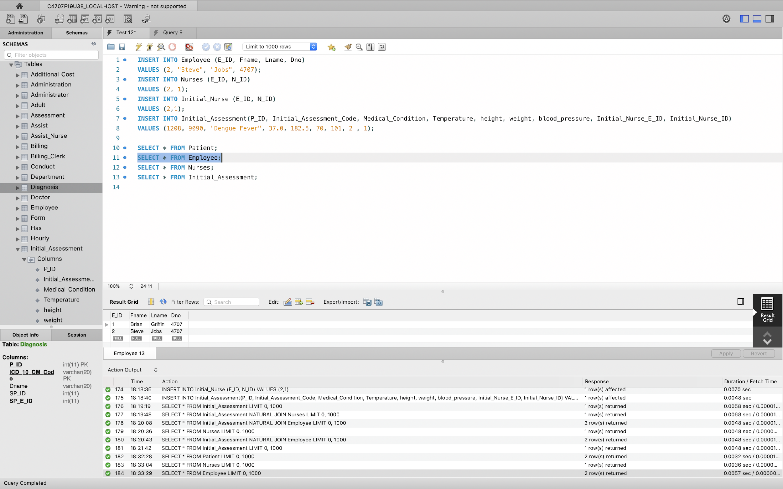

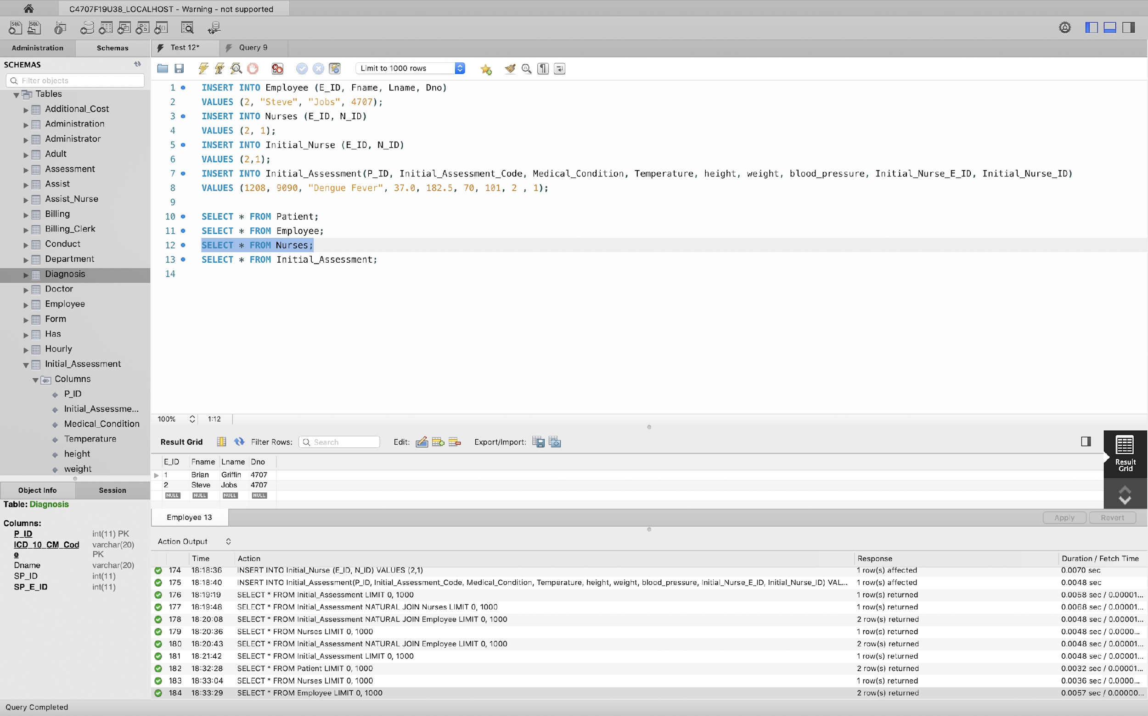

**Inserted an Initial Assessment into Initial Assessment table**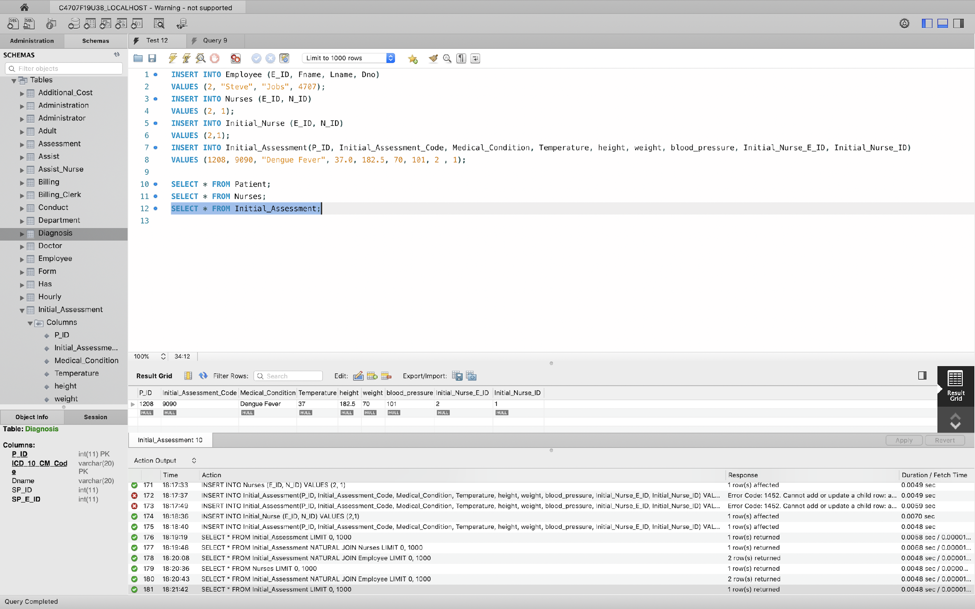

**SQL Query(s) used for testing:**

**INSERT INTO Employee (E_ID, Fname, Lname, Dno)**

**VALUES (2, "Steve", "Jobs", 4707);**

**INSERT INTO Nurses (E_ID, N_ID)**

**VALUES (2, 1);**

**INSERT INTO Initial_Nurse (E_ID, N_ID)**

**VALUES (2,1);**

**INSERT INTO Initial_Assessment(P_ID, Initial_Assessment_Code, Medical_Condition, Temperature, height, weight, blood_pressure, Initial_Nurse_E_ID, Initial_Nurse_ID)**

**VALUES (1208, 9090, "Dengue Fever", 37.0, 182.5, 70, 101, 2 , 1);**

**SELECT * FROM Patient;**

**SELECT * FROM Employee;**

**SELECT * FROM Nurses;**

**SELECT * FROM Initial_Assessment;**

**Explanation**: Nurse’s information is provided in the initial such as the Nurses ID, and the Employee ID of the Nurse. But the name of the nurse would not be shown form the Initial Assessment. A Join condition would have to be applied to view this information.